# System Design

## Data Modelling

## High level ER

Low level

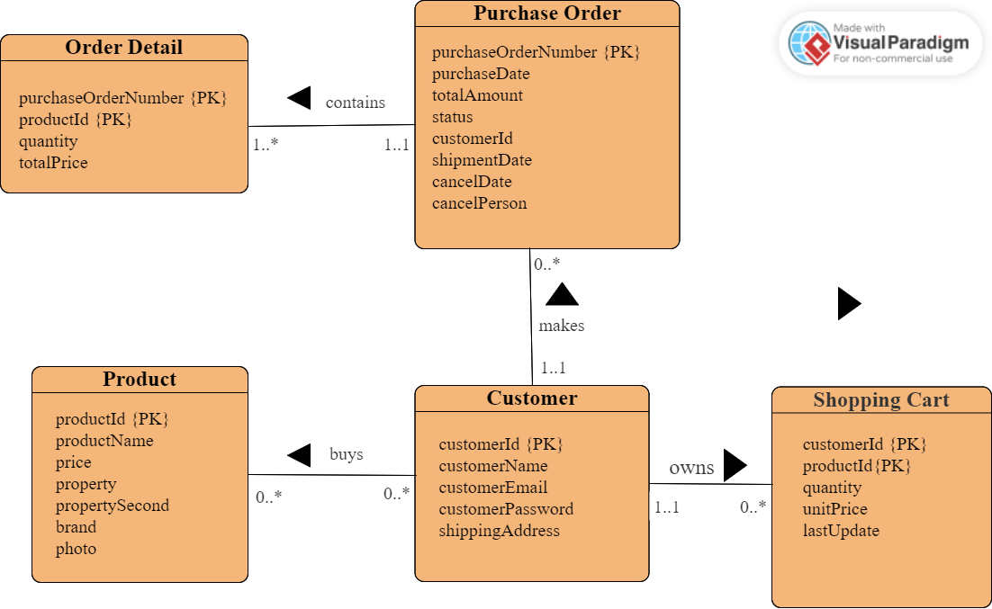

Figure illustrates our ER diagram for Niubility. The main entities are:

* Customer: This entity stores information about each customer who registers on our website, including their names, email addresses, password and shipping addresses.
* Product: This entity stores information about each product that is available for sale on Niubility, such as its name, price, two properties, brand and photo.
* Shopping Cart: This entity stores information about each product the customer wants which includes its quantity, unit price and date when it is added.
* Purchase Order: This entity stores information about each order the customer makes, like purchase date, total amount, order status and customer Id. If the products of this order are shipped, it will record the shipment date. Or the order is canceled, it will record cancel person and cancel date.
* Order Detail: This entity stores the detailed information of each order, such as the specific product(productId), the number of the specific product and the total price of this product.

The relationships between these entities are:

* A customer can buy zero or many products. A product can be bought by zero or many customers.
* A customer can own zero or many shopping carts(Note: the entity Shopping Cart records one product and one customer at one time. You could read the figure below to get better understanding). A shopping cart can be owned by one and only one customer.
* A customer can make zero or more purchase orders. A purchase order can be made by one and only one customer.
* A purchase order can contain one or many order details. But a order detail can be contained by one and only one purchase order.

|  |  |  |  |  |
| --- | --- | --- | --- | --- |
| customerId | productId | quantity | unitPrice | lastUpdate |
| 1 | 6 | 2 | 5000 | 2023-3-26 15:00:06 |

## 3.2 Dynamic Modelling

The dynamic modelling chapter of an online shopping mall project report should describe how the system behaves over time. In this section, we present the dynamic model for our mobile online shopping application. We use state diagrams, activity diagrams and sequence diagrams to show the different states that a user can be and how different activities are performed in the system and also show their interactions with actors (or users) and objects (or entities).

### **State Diagrams**

The state diagrams for our mobile online shopping mall shows the different states that a user can be in while using the system. In our project, there are total five state diagrams that represent different aspects of our project system. For example, we have the main state diagram to show all possible states of a customer, the account management state diagram to display how customers manage their own accounts, the state diagram to describe the process of customers who are not logged in, the state diagram to show the process of the logged-in customers, and the state diagram to illustrate the process of vendor.

Figure 3-2-1 below shows the main state diagram of our mobile application. In this diagram, customers first should be the Login state or Registration state. If the customers don’t have their accounts, they should go to Registration state to create new accounts. After registration, they can go to Product List Page

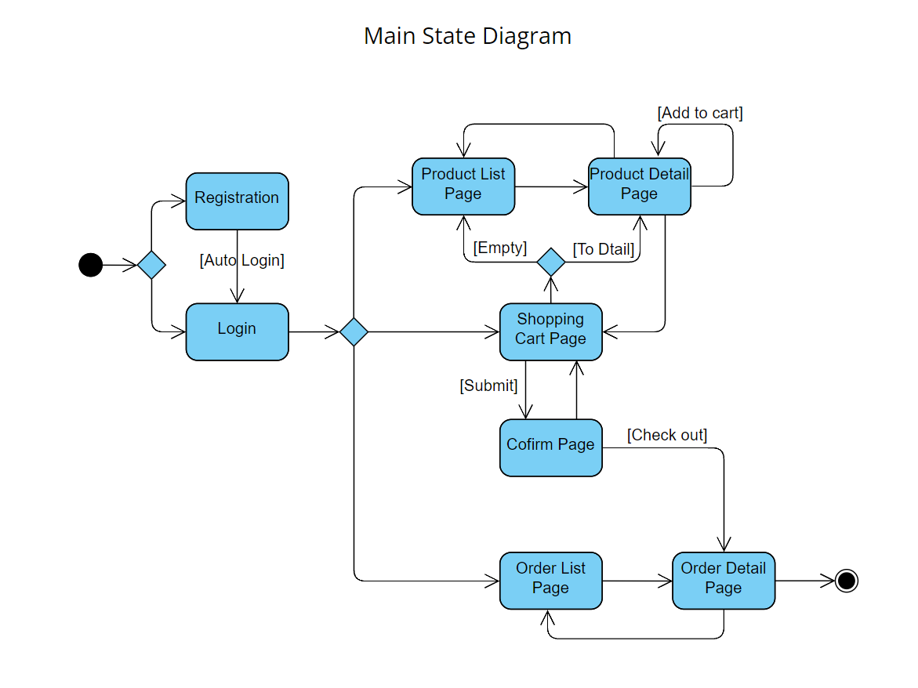

Figure 3-2-1: Main State Diagram

Figure 3-2-2 below shows the account management state diagram for customers.

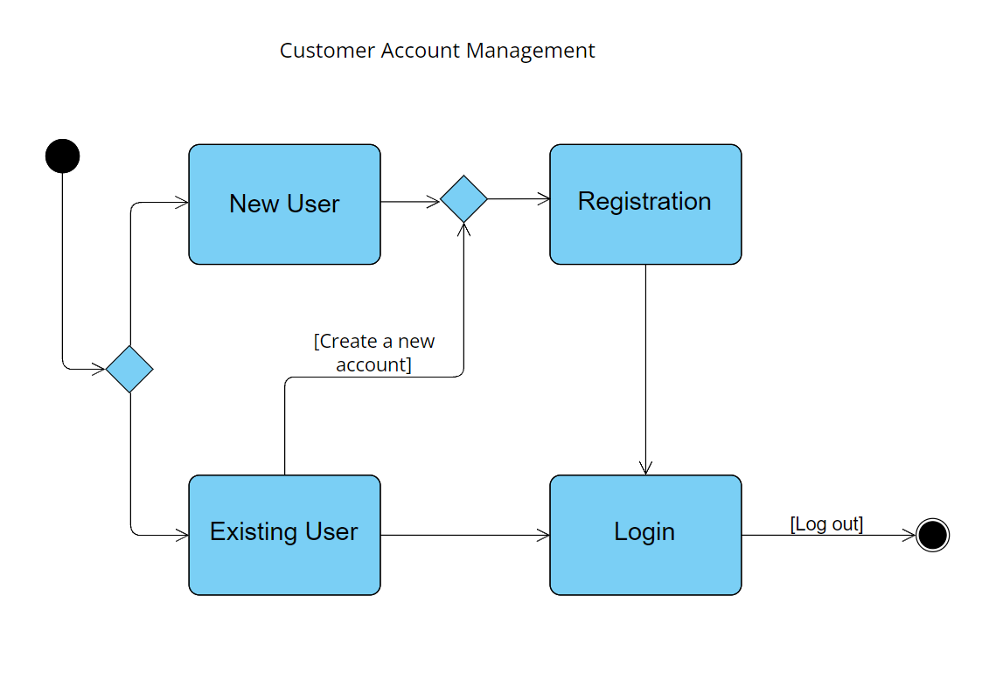

Figure 3-2-2: Account Management

Figure 3-2-3 below shows the state diagram to describe the process of customers who don’t have an account or don’t logged in.

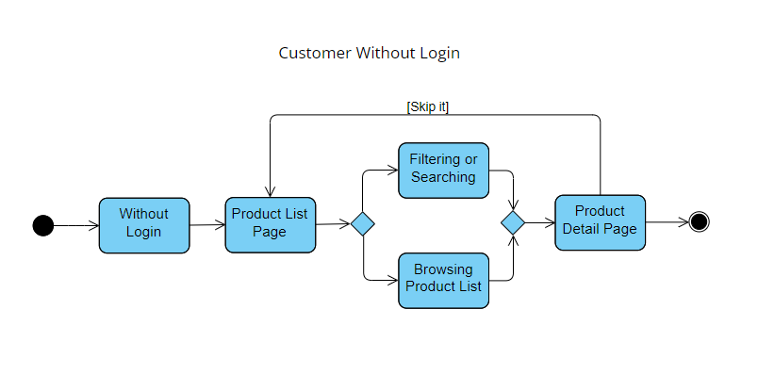

Figure 3-2-3: Not Logged In

Figure 3-2-4 below shows the state diagram to describe the process of logged-in customers.

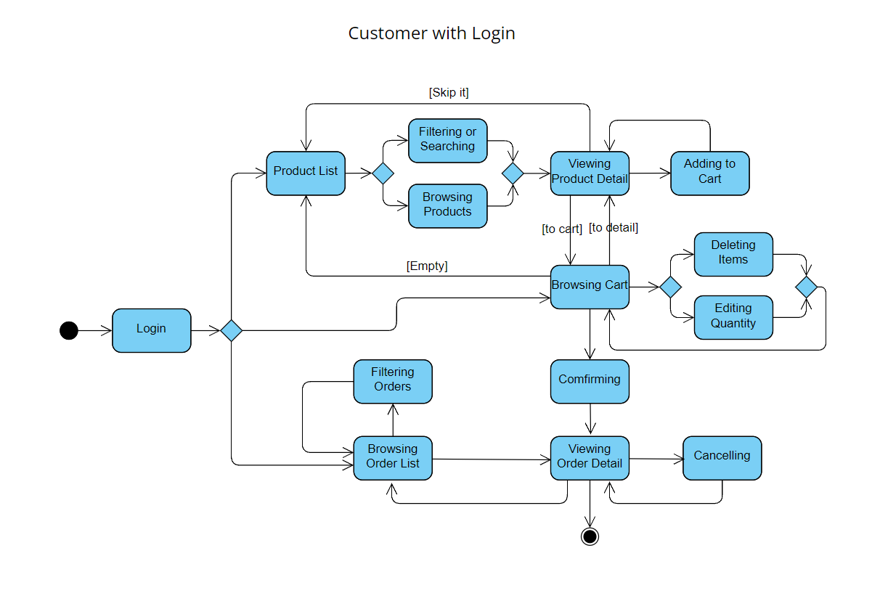

Figure 3-2-4: Logged-in Customers

Figure 3-2-5 below shows the state diagram to describe the process of logged-in customers.

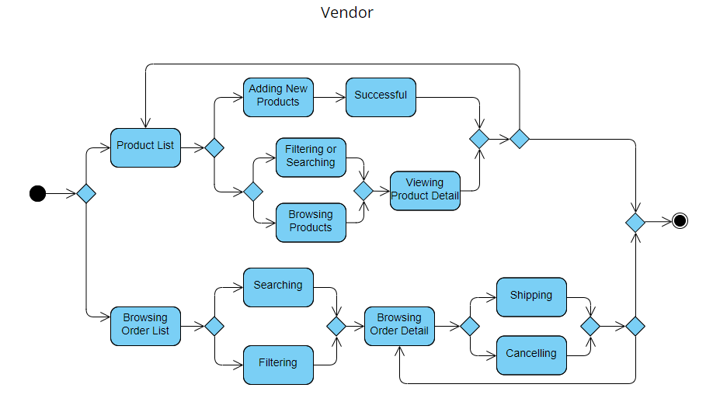

Figure 3-2-5: Vendor

### **Activity Diagrams**

Figure 3-2-6 below shows the activity diagram of customers.

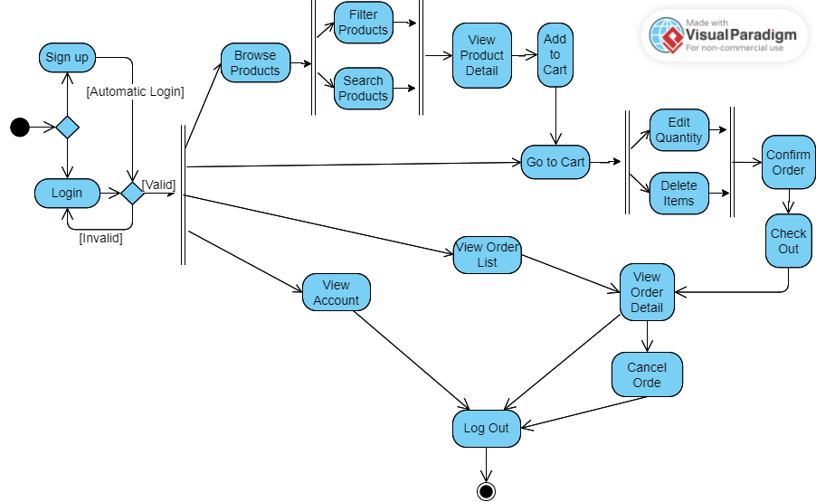

Figure 3-2-6: Activity Diagram of Customers

Figure 3-2-7 below shows the activity diagram of customers.

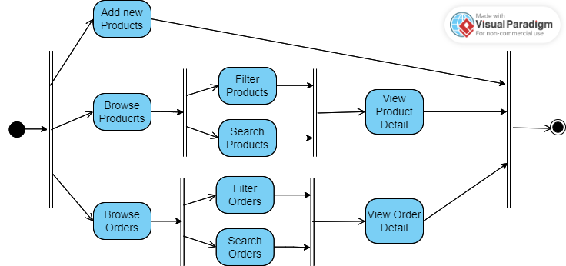

Figure 3-2-7: Activity Diagram of Vendor

